MINUTES OF THE MEETING OF WATER ORTON PARISH COUNCIL
held on Thursday 28th September 2023 at 7.00pm at the Pavilion, Open Field Croft.
Present: Cllr S. Stuart (Chair), Cllr K. Brown, Cllr. C. Chown, Cllr. R. Coldrick, Cllr. R. Lowe Cllr. W. Rees.
Guests in Attendance: County Councillor Watson, Borough Councillor Reilly, Parish Councillor Stuart is also a Borough Councillor.
Public in Attendance: 5
Minute Taker & Clerk: Rachel Scully, clerk@wopc,org,uk
23/065. Apologies: Cllr. N. Freeman
23/066. Report from Chairman:
23/067. Public Participation:
- Members of the public and press: None
- Reports from County and Borough Councillors: advised that received communications from HS2 about the works going ahead, delay to Curdworth/Middleton, he advised that he could send the information on. County Councillor Watson advised that he had awarded grants from his funding to Water Orton Football Club. advised that Gilson viaduct, the site is now safe, and the works have been done to Plank Lane/Birmingham Road to maintain the flooding. Discussion about the speed, surveys, they have been completed by highways, but waiting for formal report. County Cllr Watson advised that £200 had been donated to the church to top up the food bank. Borough Cllr Reilly advised of the Air Quality Survey, to measure the air quality in Water Orton village, to be funded by public health, Warwickshire County Council. General discussions surrounding, road closures, and junction closures surrounding Water Orton, causing roads to become blocked, should there be some consultation with the Parish Council, and should the utilities and highways be able to plan and co-ordinate road closures.
- Report from Police Representative: - Apologies and a written report rec’d from PCSO Demi Smith

23/068. Declarations of Interest and Dispensations: None
23/069. Minutes: It was RESOLVED to approve the minutes of the Parish Council meeting held on 27th July 2023.
It was RESOLVED to approve the minutes of the Extraordinary Parish Council meeting held on
31st August 2023.

23/070. Reports from Parish Councillors (for information only):
The Council noted the written report from Cllr Stuart into the footpath alongside Christopher Way dated, 19.09.2023.
Cllr Stuart welcomed comments about responsibility and maintaining the land which is adjacent to the school, and
working in partnership with the community. It was RESOLVED to consider reviewing the Neighbourhood Plan.
The Council noted the written report from Cllr Stuart following the Special Management Zone (SMZ) meeting which took
place in September. The proposals in the report to write to the Chair of the SMZ, to review all outstanding actions
relating to Water Orton, particularly matters relating to open publishing of data. To invite the Chair of SMZ to visit
Water Orton and meet with local residents.

23/071. Clerk Report: The Clerk report was noted. It was RESOLVED to agree the Pavilion Hire, and for the Clerk to explore the options for payment of Parish Council expenses to staff.
23/072. Correspondence a) Discussions and proposals, about approaching local businesses involved to support the cost of the Christmas lights, for advertising, enquiries into alternate storage. It was RESOLVED to agree costs of Christmas lights for this year, but to review and investigate the cost of installation of Christmas lights for next year. b) Electric Vehicle Chargers, it was suggested that if any Councillors, or the public have any ideas of suitable locations to send them onto the Clerk. c) D-DAY, involvement of Parish Councils, proposal failed.

23/073. Remembrance Day: The Vicar, Paul Tullet was welcomed to the meeting, and he outlined the details of the memorial service for Remembrance Day. It was RESOLVED that the Parish Council would purchase a wreath, and the Clerk would look into and purchase a wreath from the British Legion, and that Paul would look into a service for D-Day.
23/074. Allotments: Cllr Brown gave some brief outline information, the item was deferred to the next meeting.
23/075. Planning:
- The below planning applications were considered:
Reference | Address | Details | WOPC Comments
PAP/2022/0522 | Land adjacent to Dog Inn Marsh Lane Water Orton (Grid ref: Easting 417708.29, Northing 291269.18) | Notification of Amended Plans/Description The changes are: Plot 7-Chimney and gable roof feature added Plot 9- Garage relocated to western side 2 no. additional trees added to the front of property adjacent to drive 1 no. additional tree and area of planting Added to turning area in front of plot 9 Hedge to easter boundary of plot 9 extended to full length | Comments were due before 24/09/2023. Email sent to Ian Griffin, at North Warwickshire, advising that WOPC will submit comments after the full council meeting held on 28/09/23. Emailed in response received 14/09/2023 from Ian Griffin noting that the Parish Council have already considered the proposal twice at meetings and also before the application was submitted. He is ok with comments after 28/9, but it must be noted they may not make onto a Board report, as they are due to take it to the October 9th meeting, so will have to be reported later
PAP/2023/0369 | 30 Overton Drive Water Orton B46 1QL (Grid Ref: 418185, Northing 291052.44 | Erection of orangery | Expires before the end of the working day on 08/10/23
PAP/2023/0398 | West Side of Gypsy Lane, Water Orton (Grid Ref: Easting 418519.77, Northing 290744,59) | Prior Notification of proposed Prior Installation of telecommunications base station, comprising 25m lattice mast supporting 6 no antenna, 4 no dishes,  together with ground-based equipment cabinets and ancillary development.
For application PAP/2022/0522 the Heritage Group have passed comments onto the developer. No comments to be raised for application PAP/2023/0369., PAP/2023/ 0369. Comment made that works have started on the property, Cllr Stuart advised that enquiries need to be raised and reported directly to planning.

For PAP/2023/0398, it was RESOLVED, an objection would be made based on the siting and appearance of the installation, being on greenbelt land. Clerk to respond on behalf of the Parish Council.

- The below decision on a previous planning application made by NWBC was noted.
Reference | Address | Details | WOPC Comments | NWBC Decision
PAP/2023/0292 | 3, Digby Crescent, Water Orton, B46 1NP | Double storey extension to side of dwelling and single to rear, with porch to front | None | Granted

23/076. Maintenance
- The monthly play inspection report from Cllr Chown was noted. It was RESOLVED that Cllr Chown would get in touch with the company who deals with maintenance and repair of the play areas, to obtain a quote to be reviewed at a future meeting when he has the information available.

23/077. Finance:
- It was RESOLVED to approve the payment schedule for August and September and items paid under delegated authority since the previous schedule. (APPENDIX 10)

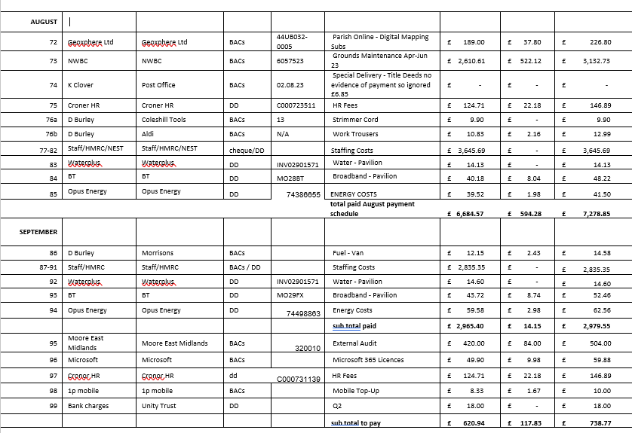

- It was RESOLVED to approve the 2023-24 Accounts and Bank Reconciliation to 20th September 2023. (APPENDIX 10a)
- It was RESOLVED to approve the cost in the sum of £504, of Signed External Auditor Report, for Audit Report and Certificate 2022/2023 (APPENDIX 10b, 10c and 10d).
- It was RESOLVED to move this item to the end of the meeting.

23/078. Policies
- It was RESOLVED to refer consideration of Outdoor Hire Agreement and Associated Procedures (via maintenance sub-committee).
- It was RESOLVED fees for October Hire for 2023-2024 will be considered (via finance sub-committee).
- It was RESOLVED that the tracker items, from the Document Review Tracker, highlighted in yellow, (APPENDIX 11) will be accepted until 31st May 2023.
- It was RESOLVED to accept the Risk Management Assessment for Clerk Handover/Loss of Clerk (APPENDIX 12)
23/079. Items for the next meeting/s: Policies: Consideration of fees for Outdoor Hire for 2023-24 (via Finance sub-committee); review of neighbourhood plan on annual basis; consultation of road closures, and road safety due to volume of traffic; consider mailing list, facebook page in relation to notifications.
23/080. Date, Time and Place of the next Parish Council Meeting: It was RESOLVED that the next Parish Council Meeting is to be held on Thursday 26th October 2023 at 7pm at The Playing Field Pavilion, Openfield Croft. The Parish Councillor Surgery will be held beforehand from 6:30pm-7pm.
23/081. Closed Session: The meeting did not move into a closed session.

23/082. Agenda Items moved during the meeting under Standing Order 10 a) vi.

Item: 13d) It was RESOLVED for the finance sub-committee to meet on 12/10/2023 at 18:30 at The Pavilion

There being no further business the Chairman declared the meeting closed at 20.25

........................................................ Signed ............................................. Date

